DHS, Class of ‘67
50-Year Reunion
Reunion Letter #3
September 14-16, 2017
July 2017

Everyone knows how fast the summer goes. September will be here before you know it. Now is the time to make your plans to attend our 50-Year High School Reunion. This reunion could be our last – no one knows.
Please help the Reunion committee with our planning by going online today and completing your RSVPs for each event and buying your ticket(s). Your commitment ASAP is greatly appreciated so that we can plan food choices, prepare photo name badges, and organize other details.
Some of you have RSVP’d for each event but have not yet purchased your ticket(s). Some of you have bought your ticket(s), but have not yet RSVP’d. You need to do both actions – RSVP and purchase ticket(s).

While the Thursday evening Junior High Event and the Friday evening Casual Event are “pay your own way” events, if you plan to attend those events only, we ask that you still buy a Reunion ticket(s). We incur many expenses in planning and organizing our reunion. And we sure hope you do attend the Main Event on Saturday evening.

Please check your profile for accuracy, and definitely complete your Comments section (up to 125 words, or else we will have to edit). If you’d like, add a current photo. We’d all love to see it. Whether or not you plan to come to the Reunion, be sure to complete your profile. We really do want to know more about you.

Also, be sure to complete the survey. Then, click on the results to see the aggregate of responses. The results are more “true” when many people complete the survey.
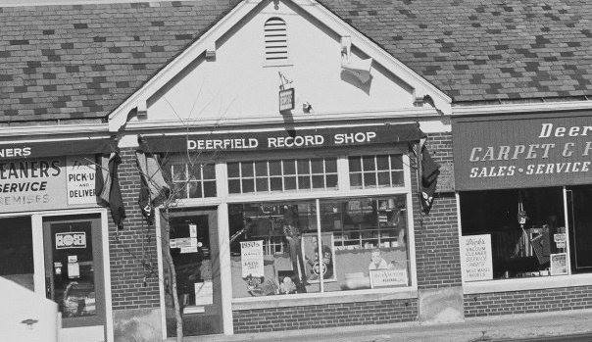
Start thinking about bringing memorabilia and old photos for our memorabilia table. With photos, we suggest you scan your originals and bring the copy. At the end of the evening, remember to take your items home.

Be sure to read the “Latest News” and “Frequently Asked Questions” sections our website. The FAQ will answer many of your questions.

Enclosed is the Missing and Unconfirmed list. If you are on this list, please contact us to verify your information, especially your email address.
Whether you are attending the reunion or still debating the subject, consider the following:
- Think back a mere 63 years ago to when we were in kindergarten. Then, think about the good old days of first grade when we learned to read, “See Dick run. See Jane run. See Dick and Jane run.” Time really does fly. Let us not pass up this opportunity to be together as a class at least one more time, to have fun, to laugh, to feel young, and to enjoy life to its fullest in the here-and-now.
- When you attend this Reunion, be mindful of one of the great joys of attending any reunion: It’s not just seeing old friends, though that experience alone will be great, but it’s talking with classmates you barely knew or didn’t know at all, only to find out what nice people they are (and they were always nice) – we were just too busy or not open-minded enough to enjoy the company of a variety of people. Youth really is wasted on the young. Ahhhhh, to be young again (and know what we know now).
- Where are we now, and how did we get there? Take a trip down memory lane, and begin to discover those answers for yourself in September.

Thank you and all the best,

Tony Tempesta, Gail Duberchin Baccetti, Carol Parker McConnell
DHS Class of ’67
Reunion Committee

Our website: www.dhs67reunion50.myevent.com
Our e-mail address: dhsreunion67@gmail.com

Our street address for mailing checks for tickets, donations, and Reunion Book orders:

DHS67Reunion50 (Make out check to DHS67Reunion50)
Gail Duberchin Baccetti
1266 Geneva National Ave. W.
Lake Geneva, WI 53147
If we don’t have your email address, you have received this letter in the mail. Please let us know your email address! Email is faster and helps our reunion budget.

If we do have your email address, you will receive this letter and future communications only by email.

